**Experiment No : 03**

**Experiment Name :** Analog Communication Through Optical Fiber.

**Objective:**

Setting up fiber optics analog link and verification through voice signal.

**Theory:**

Fiber optics can be used for transmission of digital as well as analog signal. Basically a fiber optics link contains three main elements, a transmitter, optical fiber and receiver. The transmitter modules take the input signal in electrical form and then transform it into optical energy containing the same information. The optical fiber is the medium, which takes the energy to the receiver. At the receiver light is converted back into receiver into electrical form at the same pattern as to originally fed to the transmitter

**Apparatus:**

**Transmitter:** Fiber optics transmitters are typically composed of buffer, driver and optical source. The buffer provides both an electrical connection and isolation between the transmitter & the electrical system supplying of the data. The driver provide the electrical power to the optical source finally, the optical source converts.

**Fiber Optic Link:** Emitter and detector circuit on board form the fiber optic link. This section provides the light detector at the far end of the fiber optic links. The optic fiber plugs into the connectors provided in this part of the board. Two separate links are provided.

**The Receiver:** The comparator circuit, Low Pass Filter, Phase Locked Loop, AC Amplifier circuit form receiver on the board. It is able to undo the modulation process in order to recover the original information signal. In this experiment the trainer board is used to

illustrate One-Way communication between digital transmitter and receiver circuits.

**Mouthpiece (microphone):** This is used as a signal input device, Voice signal is captured and transmitted through the mic.

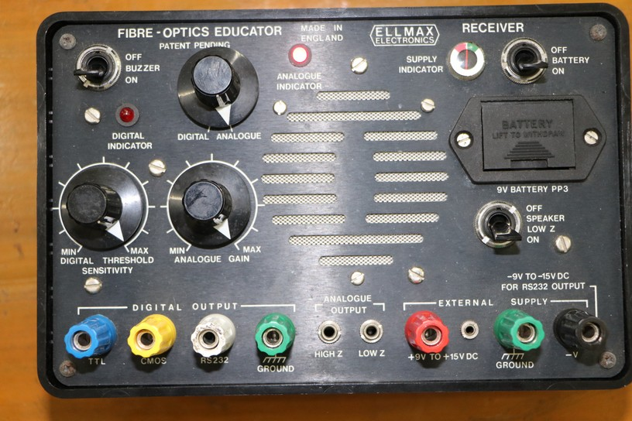

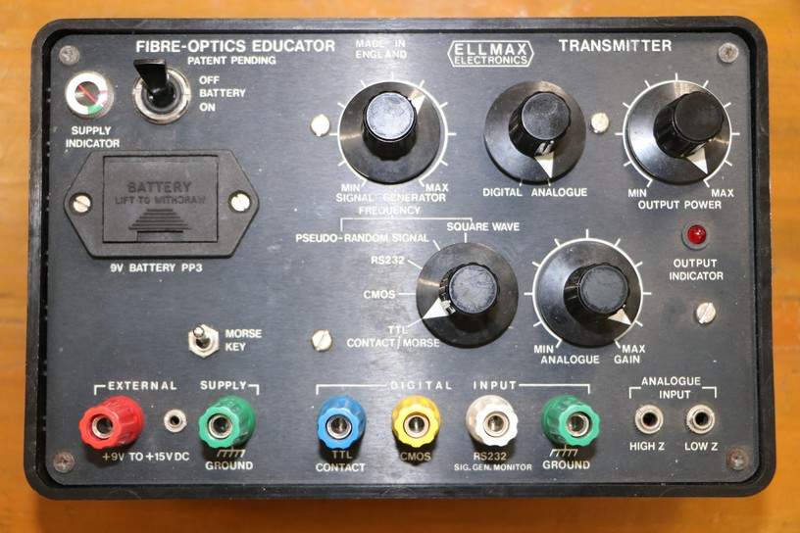

**Transmitter Receiver**

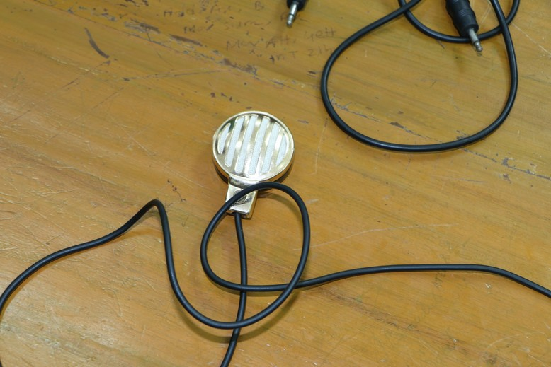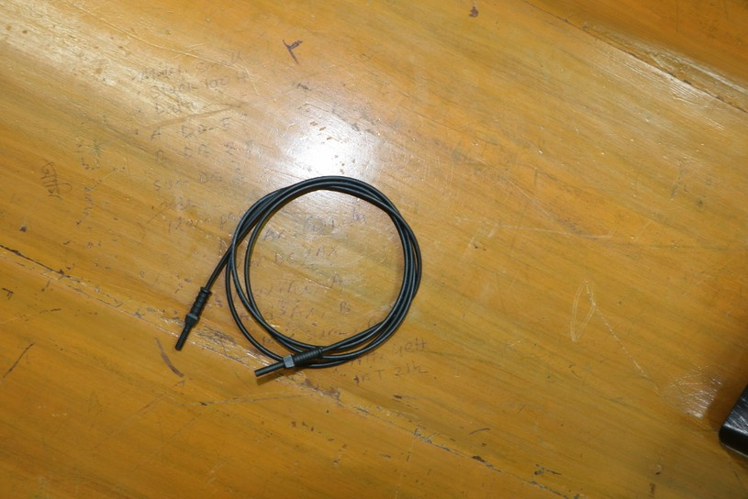 **Fiber Optic Link Mouthpiece (microphone)**

**Procedure:**

* Connect the power supply to the board.
* Make the optical fiber connections properly
* Turn the signal generator block to fully clock wise (max. amplitude) position.
* Switch on the power supply.
* The output from the detector is amplified by AC amplifier. This amplifier increases the amplitude of the received signal, and also removes the DC component, which is present at detector O/P. monitor the O/P of amplifier and adjust the gain adjust preset until the monitored signal has same amplitude as that applied to emitter I/P.
* Observe that same audio output is available on the speaker as fed to the microphone.
* Try a reflector removing the optical fiber and observe the output signal quality.